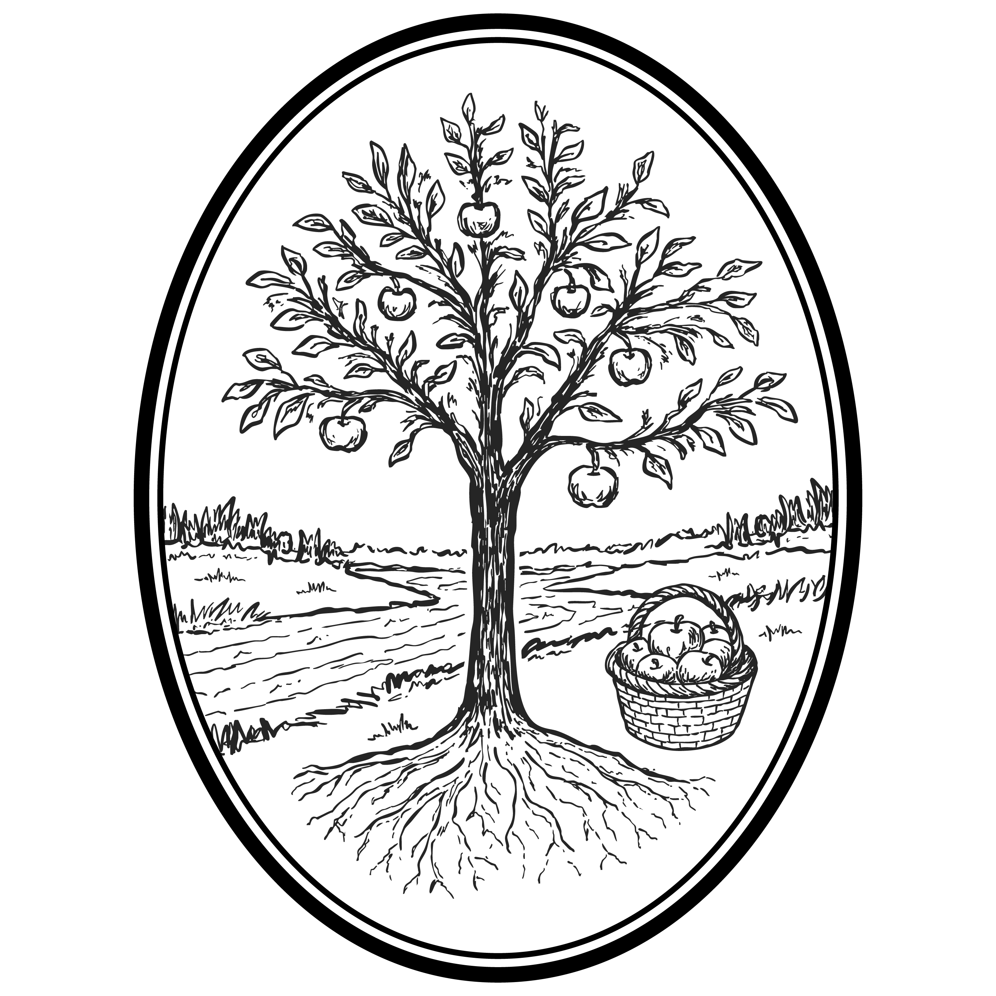
Invite Involve Instruct Inspire
October 12, 2025 | 9 am
Welcome
The Eighteenth Sunday after Pentecost
When it comes to water in scripture, God tends to display a reckless abundance. Today we see an example of this abundance in our Ezekiel reading. The water in this vision is leaking out of the doors of the Temple, trickling out the gates. And it gathered together, more water, and more water, until it was deep enough to be over Ezekiel’s head — a mighty river.
And wherever the water went, there was life. Trees, fruits, animals, fish. The water doesn’t exist for itself, but to nourish all the life that depends on it. And herein lies a deep truth about God’s love for the world — God’s love nourishes life.
At least in today’s vision of Ezekiel, all the water flows from the Temple (the place of worship for the people of Israel and the point where heaven and earth meet). And clearly, the Temple was leaky. Thanks be to God, the Temple was leaky. Imagine if it wasn’t. Imagine if the Temple just dammed up the water, and the waters rose and rose inside. Then all God’s worshipping people would drown, and the world outside would be dry and barren.
The Temple, and in our case St. Andrew’s (the place of worship for the people of this parish, and the place where heaven and earth meet at the altar), are to be the source of living water for the world, but not the water’s destination. The water, God’s loving grace, is to nourish life in the world. When it comes to God’s grace, Christ Church is supposed to be leaky. Let it flow! Let it flow!
As we continue in this season of stewardship, and as you prayerfully consider your own giving in the coming year, I pray you’ll be inspired by this vision of a leaky church, from which the water of God’s grace spills out into the world and brings forth life.
- Father Andrew
Once the Prelude begins, please refrain from further visiting and conversation as we prepare our hearts and thoughts for worship. Prayers before worship can be found in the Book of Common Prayer, p. 833-35.

Prelude

The Word of God

Please stand.

Processional
Shall we gather at the river

Shall we gather at the river,

Where bright angel feet have trod;

With its crystal tide forever

Flowing by the throne of God?

Yes, we'll gather at the river,

The beautiful, the beautiful river;

Gather with the saints at the river

That flows by the throne of God.

On the margin of the river,

Washing up its silver spray,

We will walk and worship ever,

All the happy golden day.

Remain standing.

Opening Acclamation
Celebrant Blessed be God: ✠ Father, Son, and Holy Spirit.
People And blessed be his kingdom, now and for ever. Amen.

Almighty God, to you all hearts are open, all desires known, and from you no secrets are hid: Cleanse the thoughts of our hearts by the inspiration of your Holy Spirit, that we may perfectly love you, and worthily magnify your holy Name; through Christ our Lord. Amen.

Song of Praise
Revelation Song
Worthy is the
Lamb who was slain;
Holy, holy is he;
Sing a new song
to him who sits on
heaven’s mercy seat.

Holy, holy, holy
is the Lord God Almighty.
Who was and is and is to come;
With all creation I sing
praise to the King of kings;
you are my everything
and I will adore you.

Collect of the Day
Celebrant The Lord be with you.
People And also with you.
Celebrant Let us pray.

Lord, we pray that your grace may always precede and follow us, that we may continually be given to good works; through Jesus Christ our Lord, who lives and reigns with you and the Holy Spirit, one God, now and for ever. Amen.

Be seated.

Children’s Sermon

The Scriptures: Ezekiel 47:1-12
Then the man in the vision of God brought me back to the entrance of the temple; there water was flowing from below the entryway of the temple toward the east (for the temple faced east), and the water was flowing down from below the south side of the temple, south of the altar. Then he brought me out by way of the north gate and led me around on the outside to the outer gate that faces toward the east, and the water was trickling out on the south side.
Going on eastward with a cord in his hand, the man measured one thousand cubits and then led me through the water, and it was ankle-deep. Again he measured one thousand and led me through the water, and it was knee-deep. Again he measured one thousand and led me through the water, and it was up to the waist. Again he measured one thousand, and it was a river that I could not cross, for the water had risen; it was deep enough to swim in, a river that could not be crossed. He said to me, “Mortal, have you seen this?”
Then he led me back along the bank of the river. As I came back, I saw on the bank of the river a great many trees on the one side and on the other. He said to me, “This water flows toward the eastern region and goes down into the Arabah, and when it enters the sea, the sea of stagnant waters, the water will become fresh. Wherever the river goes, every living creature that swarms will live, and there will be very many fish once these waters reach there. It will become fresh, and everything will live where the river goes. People will stand fishing beside the sea from En-gedi to En-eglaim; it will be a place for the spreading of nets; its fish will be of a great many kinds, like the fish of the Great Sea. But its swamps and marshes will not become fresh; they are to be left for salt. On the banks, on both sides of the river, there will grow all kinds of trees for food. Their leaves will not wither nor their fruit fail, but they will bear fresh fruit every month, because the water for them flows from the sanctuary. Their fruit will be for food and their leaves for healing.”

After the reading, the Reader will say
The Word of the Lord.
People Thanks be to God.

Psalm 111
Read in unison.
Hallelujah!
I will give thanks to the Lord with my whole heart,
in the assembly of the upright, in the congregation.
Great are the deeds of the Lord!
they are studied by all who delight in them.
His work is full of majesty and splendor,
and his righteousness endures for ever.
He makes his marvelous works to be remembered;
the Lord is gracious and full of compassion.
He gives food to those who fear him;
he is ever mindful of his covenant.
He has shown his people the power of his works
in giving them the lands of the nations.
The works of his hands are faithfulness and justice;
all his commandments are sure.
They stand fast for ever and ever,
because they are done in truth and equity.
He sent redemption to his people;
he commanded his covenant for ever;
holy and awesome is his Name.
The fear of the Lord is the beginning of wisdom;
those who act accordingly have a good understanding;
his praise endures for ever.

Please stand.

Sequence Hymn
Thy Word
Thy Word is a lamp unto my feet
and a light unto my path.
Thy Word is a lamp unto my feet
and a light unto my path.

When I feel afraid,
and I think I’ve lost my way,
still you’re there right beside me.
Nothing will I fear
as long as you are near.
Please be near me to the end.

Remain standing.

The Gospel: Luke 17:11-19
The Deacon or a Priest reads the Gospel, first saying
The Holy Gospel of our Lord Jesus Christ according to Luke.
People Glory to you, Lord Christ.

On the way to Jerusalem Jesus was going through the region between Samaria and Galilee. As he entered a village, ten lepers approached him. Keeping their distance, they called out, saying, "Jesus, Master, have mercy on us!" When he saw them, he said to them, "Go and show yourselves to the priests." And as they went, they were made clean. Then one of them, when he saw that he was healed, turned back, praising God with a loud voice. He prostrated himself at Jesus' feet and thanked him. And he was a Samaritan. Then Jesus asked, "Were not ten made clean? But the other nine, where are they? Was none of them found to return and give praise to God except this foreigner?" Then he said to him, "Get up and go on your way; your faith has made you well."

After the Gospel, the Reader will say
The Gospel of the Lord.
People Praise to you, Lord Christ.

Be seated.

Sermon
The Rev. Logan Hurst

Please stand.

The Nicene Creed
We believe in one God, the Father, the Almighty, maker of heaven and earth, of all that is, seen and unseen.
We believe in one Lord, Jesus Christ, the only Son of God, eternally begotten of the Father, God from God, Light from Light, true God from true God, begotten, not made, of one Being with the Father. Through him all things were made. For us and for our salvation he came down from heaven: by the power of the Holy Spirit he became incarnate from the Virgin Mary, and was made man. For our sake he was crucified under Pontius Pilate; he suffered death and was buried. On the third day he rose again in accordance with the Scriptures; he ascended into heaven and is seated at the right hand of the Father. He will come again in glory to judge the living and the dead, and his kingdom will have no end.
We believe in the Holy Spirit, the Lord, the giver of life, who proceeds from the Father and the Son. With the Father and the Son he is worshiped and glorified. He has spoken through the Prophets. We believe in one holy catholic and apostolic Church. We acknowledge one baptism for the forgiveness of sins. We look for the ✠ resurrection of the dead, and the life of the world to come. Amen.

Prayers of the People
Let us pray for the Church and for the world.

Grant, Almighty God, that all who confess your Name may be united in your truth, live together in your love, and reveal your glory in the world. Silence

Lord, in your mercy, Hear our prayer.

Encourage and inspire our ministries, especially Lay Eucharistic Visitors, Lay Readers and Lunch Bunch at the Samaritan Inn, that our labor would bear fruit in our common life and in your eternal kingdom. Silence

Lord, in your mercy, Hear our prayer.

Inspire our hearts with the confidence that we are planted in your promise, and guide us to respond with generosity and hope this stewardship season. Silence

Lord, in your mercy, Hear our prayer.

Guide the people of this land, and of all the nations, in the ways of justice and peace; that we may honor one another and serve the common good. Silence

Lord, in your mercy, Hear our prayer.

Give us all a reverence for the earth as your own creation, that we may use its resources rightly in the service of others and to your honor and glory. Silence

Lord, in your mercy, Hear our prayer.

Strengthen, guide, and protect those in our community struggling to put their lives together after deep suffering, especially the women and children at Shiloh Place and the families served by Ragan’s Hope, and all those who visit the McKinney Little Free Pantry. Silence

Lord, in your mercy, Hear our prayer.

Bless all whose lives are closely linked with ours, and grant that we may serve Christ in them, and love one another as he loves us. Silence

Lord, in your mercy, Hear our prayer.

Comfort and heal all those who suffer in body, mind, or spirit; give them courage and hope in their troubles, and bring them the joy of your salvation. Silence

Lord, in your mercy, Hear our prayer.

We commend to your mercy all who have died ✠, that your will for them may be fulfilled; and we pray that we may share with all your saints in your eternal kingdom. Silence

Lord, in your mercy, Hear our prayer.

The Celebrant concludes with a suitable Collect.

Confession of Sin
The Deacon or a Priest says
Let us confess our sins against God and our neighbor.
Most merciful God, we confess that we have sinned against you in thought, word, and deed, by what we have done, and by what we have left undone. We have not loved you with our whole heart; we have not loved our neighbors as ourselves. We are truly sorry and we humbly repent. For the sake of your Son Jesus Christ, have mercy on us and forgive us; that we may delight in your will, and walk in your ways, to the glory of your Name. Amen.

The Priest says the Absolution.
Almighty God have mercy on you, ✠ forgive you all your sins through our Lord Jesus Christ, strengthen you in all goodness, and by the power of the Holy Spirit keep you in eternal life. Amen.

Please stand.

The Peace
Celebrant The peace of the Lord be always with you.
People And also with you.

The Holy Communion

Be seated.

Offertory
Please place your offerings and Connection Cards in the offering plates as they are passed. You can also easily give online at standrewsmckinney.org/give or by scanning the QR code. If you are online with us, please also fill out a digital Connection Card at standrewsmckinney.org/connect.

Offering Music
Come, my Way, my Truth, my Life #487 (Hymnal 1982)
Come, my Way, my Truth, my Life:
such a way as gives us breath;
such a truth as ends all strife;
such a life as kill—eth death.

Come, my Light, my Feast, my Strength:
such a light as shows a feast;
such a feast as mends in length;
such a strength as makes___ his guest.

Come, my Joy, my Love, my Heart:
such a joy as none can move;
such a love as none can part;
such a heart as joys___ in love.

Please stand.

Doxology Old 100th
Praise God, from Whom all blessings flow;
Praise Him, all creatures here below;
Praise Him above, ye heavenly host:
Praise Father, Son, and Holy Ghost.

Remain standing.

The Great Thanksgiving
Celebrant The Lord be with you
People And also with you.
Celebrant Lift up your hearts.
People We lift them to the Lord.
Celebrant Let us give thanks to the Lord our God.
People It is right to give him thanks and praise.

It is right, and a good and joyful thing, always and everywhere to give thanks to you, Father Almighty, Creator of heaven and earth.

Here a Proper Preface is said by the Celebrant.

Therefore we praise you, joining our voices with Angels and Archangels and with all the company of heaven, who for ever sing this hymn to proclaim the glory of your Name:

Holy, holy, holy Lord (Powell) #S129 (Hymnal 1982)
Holy, holy, holy Lord, God of power and might,
heaven and earth are full of your glory.
Hosanna in the highest.
Blessed is he ✠ who comes in the name of the Lord.
Hosanna in the highest.

Please kneel or remain standing. The Celebrant continues
We give thanks to you, O God, for the goodness and love which you have made known to us in creation; in the calling of Israel to be your people; in your Word spoken through the prophets; and above all in the Word made flesh, Jesus, your Son. For in these last days you sent him to be incarnate from the Virgin Mary, to be the Savior and Redeemer of the world. In him, you have delivered us from evil, and made us worthy to stand before you. In him, you have brought us out of error into truth, out of sin into righteousness, out of death into life.

On the night before he died for us, our Lord Jesus Christ took bread; and when he had given thanks to you, he broke it, and gave it to his disciples, and said, “Take, eat: This is my Body, which is given for you. Do this for the remembrance of me.” (✠)

After supper he took the cup of wine; and when he had given thanks, he gave it to them, and said, “Drink this, all of you: This is my Blood of the new Covenant, which is shed for you and for many for the forgiveness of sins. Whenever you drink it, do this for the remembrance of me.” (✠)

Therefore, according to his command, O Father,
We remember his death,
We proclaim his resurrection,
We await his coming in glory;

The Celebrant continues
And we offer our sacrifice of praise and thanksgiving to you, O Lord of all; presenting to you, from your creation, this bread and this wine.

We pray you, gracious God, to send your Holy Spirit upon these gifts that they may be the Sacrament of the Body of Christ and his Blood of the new Covenant. Unite us to your Son in his sacrifice, that we may be acceptable through him, ✠ being sanctified by the Holy Spirit. In the fullness of time, put all things in subjection under your Christ, and bring us to that heavenly country where, with Saint Andrew and all your saints, we may enter the everlasting heritage of your sons and daughters; through Jesus Christ our Lord, the firstborn of all creation, the head of the Church, and the author of our salvation.

By him, and with him, and in him, in the unity of the Holy Spirit all honor and glory is yours, Almighty Father, now and for ever. AMEN.

Please stand and, as you are comfortable, join hands with those around you.
And now, as our Savior Christ has taught us, we are bold to say,
Our Father, who art in heaven, hallowed be thy Name, thy kingdom come, thy will be done, on earth as it is in heaven. Give us this day our daily bread. And forgive us our trespasses, as we forgive those who trespass against us. And lead us not into temptation, but deliver us from evil. For thine is the kingdom, and the power, and the glory, for ever and ever. Amen.

Breaking of the Bread
Celebrant Alleluia. Christ our Passover is sacrificed for us;
People Therefore let us keep the feast. Alleluia.

Invitation
Facing the people, the Celebrant says the following Invitation
The Gifts of God for the People of God. Take them in remembrance that Christ died for you, and feed on him in your hearts by faith, with thanksgiving.

Holy Communion
All baptized Christians are invited to the altar rail to receive Holy Communion. If you are not going to receive, you’re invited to the altar rail to receive a blessing; please cross your arms over your chest.

Communion Music
Seek Ye First #711 (Hymnal 1982)
Seek ye first the kingdom of God
and his righteousness,
and all these things
shall be added unto you–
Allelu, alleluia!

Man shall not live by bread alone
but by every word
that proceeds
from the mouth of God–
Allelu, alleluia!

Humbly I adore thee, Verity unseen #314 (Hymnal 1982)
Humbly I adore thee, Verity unseen,
who thy glory hidest ‘neath these shadows mean;
lo, to thee surrendered, my whole heart is bowed,
tranced as it beholds thee, shrined within the cloud.

Taste and touch and vision to discern thee fail;
faith, that comes by hearing, pierces through the veil.
I believe whate’er the Son of God hath told;
what the Truth hath spoken, that for truth I hold.

O memorial wondrous of the Lord’s own death;
living Bread that givest all thy creatures breath,
grant my spirit ever by thy life may live,
to my taste thy sweetness never failing give.

Jesus, whom now hidden, I by faith behold,
what my soul doth long for, that thy word foretold:
face to face thy splendor, I at last shall see,
in the glorious vision, blessed Lord, of thee.

Closing Prayer
Celebrant Let us pray.
Almighty and everliving God, we thank you for feeding us with the spiritual food of the most precious Body and Blood of your Son our Savior Jesus Christ; and for assuring us in these holy mysteries that we are living members of the Body of your Son, and heirs of your eternal kingdom. And now, Father, send us out to do the work you have given us to do, to love and serve you as faithful witnesses of Christ our Lord. To him, to you, and to the Holy Spirit, be honor and glory, now and for ever. Amen.

Prayer for Lay Eucharistic Visitor
The Celebrant commissions the Lay Eucharistic Visitor, saying
In the name of this congregation, I send you forth bearing these holy gifts that those to whom you go may share with us in the Communion of Christ’s Body and Blood.
People We who are many are one body because we all share one bread and one cup.

Blessing
Celebrant … and the blessing of God Almighty, ✠ the Father, the Son, and the Holy Spirit, be among you, and remain with you always. Amen.

Closing Hymn
O for a thousand tongues to sing #493 (Hymnal 1982)
O for a thousand tongues to sing
my dear Redeemer's praise,
the glories of my God and King,
the triumphs of his grace!

My gracious Master and my God,
assist me to proclaim
and spread through all the earth abroad
the honors of thy Name.

Jesus! the Name that charms our fears
and bids our sorrows cease;
'tis music in the sinner's ears,
'tis life and health and peace.

Dismissal
The Deacon or a Priest dismisses with these words
Let us go forth into the world, rejoicing in the power of the Spirit.
People Thanks be to God.

Postlude

Ere we reach the shining river,

Lay we ev'ry burden down;

Grace our spirits will deliver,

And provide a robe and crown.

Soon we'll reach the shining river,

Soon our pilgrimage will cease;

Soon our happy hearts will quiver

With the melody of peace.
Clothed in rainbows
of living color
flashes of lightning, rolls of thunder;
Blessing and honor, strength and
glory and power be
to you, the only wise King.

Filled with wonder,
awestruck wonder,
at the mention of your name;
Jesus, your name is power,
breath and living water,
such a marvelous mystery, yeah.

I will not forget
your love for me, and yet
my heart forever is wandering.
Jesus, be my guide
and hold me by your side;
I will love you to the end



Ask and it shall be given unto you,
seek and ye shall find,
knock and the door
shall be opened unto you–
Allelu, alleluia!

If any man should want to follow me,
let him deny himself,
take up his cross
and daily follow me–
Allelu, alleluia!

He speaks; and, listening to his voice,
new life the dead receive,
the mournful broken hearts rejoice,
the humble poor believe.

Hear him, ye deaf; ye voiceless ones,
your loosened tongues employ;
ye blind, behold, your Savior comes;
and leap, ye lame, for joy!

Glory to God and praise and love
be now and ever given
by saints below and saints above,
the Church in earth and heaven.

Welcome

Have questions about our worship or St. Andrew’s? Feel free to contact Father Andrew or Father Logan at the contact information listed below.

Our worship is made possible each week by the faithful service of the members of our Altar Guild, directed by Chris Pappas, and made beautiful by the work of our flower guild, directed by Laura Verinder.
The text of the service of worship contained in this program is taken from the Book of Common Prayer 1979. The Book of Common Prayer alone is of authority in the worship of the Episcopal Church. This program is provided for convenience of use on this occasion. CCLI License No. 2626819
St. Andrew’s Staff & Vestry
The Rev. Andrew Van Kirk
Rector
andrewv@standrewsmckinney.org
The Rev. Logan Hurst
Vice Rector
loganh@standrewsmckinney.org
The Rev. Paulette Magnuson
Priest Associate
pwmagnuson@gmail.com
The Rev. Mike Klickman
The Rev. Gene Zeilfelder
Assisting Priests (Retired)
Tim Jenkins
Youth and Welcome Minister
timj@standrewsmckinney.org
Lisa Ostrowski
Outreach Minister
lisao@standrewsmckinney.org
Carolyn Nicketta
Office Administrator
carolynn@standrewsmckinney.org
Laura Bray
Children’s and Family Minister
and Music Director
laurab@standrewsmckinney.org
Michele Miller
Children’s Ministry Associate
michelem@standrewsmckinney.org
Stephanie Jenkins
Praise Band Leader
stephaniej@standrewsmckinney.org
Ned Searles
Senior Warden
Paul Miles
Junior Warden
Vestry
Eric Austin, Tracey Glenn,
Sandi Krummel, Paul Miles,
Diane Monk, Chinelo Onubogu,
Ned Searles, Peter Stringer,
Syd Verinder

